PBLJ_2.3
NAME: KARAN PRATAP SINGH UID: 23BCS10649
SECTION:23-FS_622B DATE: 6-OCT-2025

PART A: Sorting Employee Objects Using Lambda Expressions
Output:
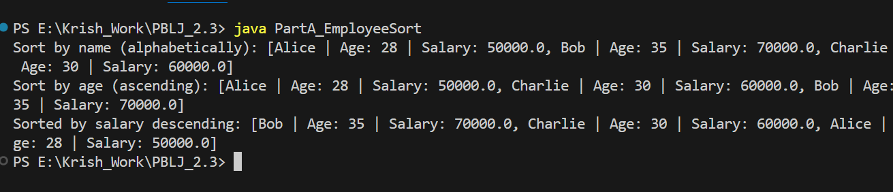

PART B: Filtering and Sorting Students Using Streams
Output:
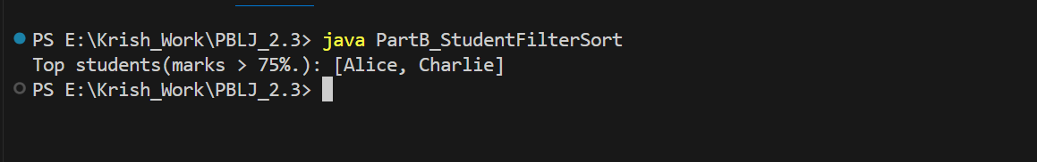

PART C: Stream Operations on Product Dataset
Output:
